This test contains synoptic questions from some of the previous three topics you’ve covered.
1 Below is a pie chart showing the composition of the atmosphere today.
a) What gas makes up 78% of the atmosphere today? (1)

b) What gas makes up 21% of the atmosphere today? (1)

The other gases in today’s atmosphere include carbon dioxide. It is thought that the Earth’s early atmosphere contained about 95% carbon dioxide. One reason for this reduction was the evolution of plants and algae.
c) What had to happen before plants could evolve? (2)

d) What is the name of the process that produces oxygen from plants? (1)

e) What else caused the amount of carbon dioxide to reduce? (1)

Many other gases such as ammonia and methane were in this early atmosphere.
f) Where did these gases come from? (1)

2 Over recent years the amount of carbon dioxide has increased as can be seen in the chart below. Carbon dioxide is a greenhouse gas.
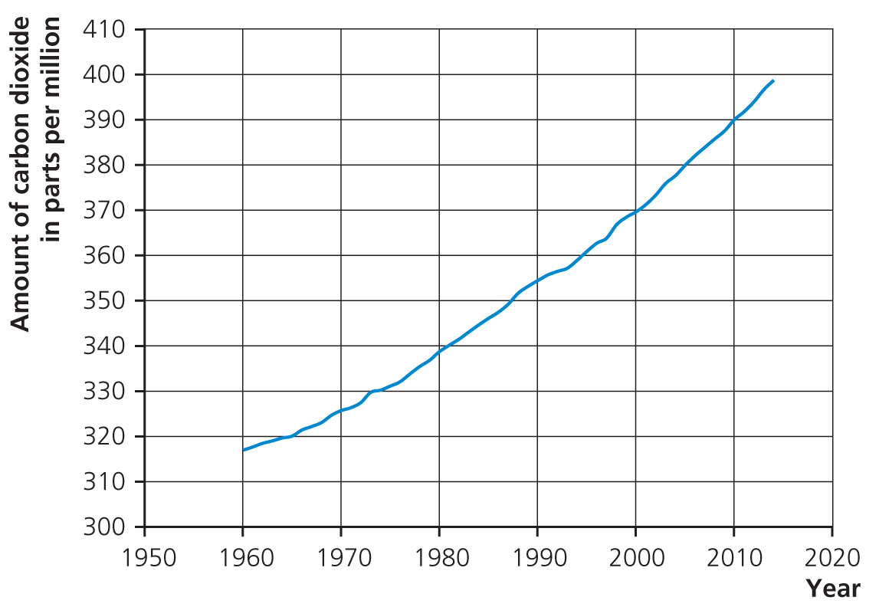
a) Carbon dioxide is a greenhouse gas. What effect is caused by greenhouse gases? What does this do to our planet? What is believed to have caused this increase? (6)

b) What would happen to the Earth if there were no greenhouse effect? (2)

3 Biofuels are sometimes described as being ‘carbon neutral’.
a) What does this mean? (2)

b) Why is it not always completely true? (2)

4 For the pollutants below, state their cause, the effect they have and how their effect can be reduced:
a) Sulfur dioxide (3)
Cause:

Effect:

Reduced:

b) Carbon monoxide (3)
Cause:

Effect:

Reduced:

5
a) What has to happen for a chemical reaction to take place? (2)

The following conditions affect the rate of a chemical reaction. Write a sentence or two to explain, using kinetic theory, how and why the following affect the rate of a chemical reaction.
b) Temperature (2)

c) Concentration (2)

d) Using a catalyst (2)

6
a) How is crude oil formed? (2)

b) How is it separated out into useful products? (2)

Many of the useful products are called alkanes.
c) What are the alkanes? (2)

Alkanes are often used as fuels. Propane is a gas used in camping stoves.
d) Write the word equation for the reaction of propane with oxygen. (2)
propane + oxygen → _____________ + ________________
e) Write the balanced chemical equation for this reaction in excess oxygen. (3)
___C₃H₈ + ___ O₂ → ______________ + _____________

7
a) What is the test for hydrogen? (1)

b) What is the test for oxygen? (1)

Compound A was analysed. It produced a lilac flame with a flame test. When dilute acid was added, a gas was produced which turned limewater cloudy.
c) What was compound A? (2)

d) What is the formula of this compound? (1)

e) What gas turns limewater cloudy? (1)

Total = 50

1
a) Nitrogen (1)
b) Oxygen (1)
c) Earth cooled and water condensed (2)
d) Photosynthesis (1)
e) Carbon dioxide was also decreased by the formation of sedimentary rocks and fossil fuels that contain carbon. (1)
f) Volcanoes (1)
2
a)
Marks
6–5 | At least three different points well expressed
4–3 | A couple of points mentioned
2–1 | Not much detail

- Effect is global warming.
- Heat is trapped in Earth’s atmosphere.
- Temperature of planet increases.
- Destroying habitats.
- Sea levels rise.
- Burning fossil fuels cause global warming.
- Deforestation also caused increase in CO₂.
b) If no greenhouse effect then Earth will be too cold for life to exist. (2)
3
a) Carbon neutral = fuels and processes whose use results in zero net release of greenhouse gases to the atmosphere. (2)
b) Most need some transportation which use fossil fuels/energy needed to make fuel. (2)
4
a) Cause: sulfur impurities in fuels (1); Effect: sulfur dioxide causing acid rain (1); Reduced: scrubbers/means of reducing sulfur dioxide from waste gases (1)
b) Cause: incomplete combustion (1); Effect: poisonous (1); Reduced: catalytic converters in cars/ensure enough oxygen (1)
5
a) Particles must collide with sufficient energy/activation energy. (2)
b) Temperature: particles move faster; collide more often and harder; more successful collisions. (2)
c) Concentration: more particles in given volume; more chance of collision. (2)
d) Catalyst: reduces activation energy; more have energy to react; therefore more successful collisions. (2)
6
a) Crude oil is formed when dead sea creatures fall to bottom of sea. Over millions of years they decompose into oil. (2)
b) Separated by: heating oil, put into fractional distillation tower, separate out due to different boiling points. (2)
c) Homologous series of hydrocarbons (2)
d) water + carbon dioxide (2)
e) C₃H₈ + 5O₂ → 3CO₂ + 4H₂O (3)
7
a) Squeaky pop (1)
b) Relights glowing splint (1)
c) Potassium carbonate (2)
d) K₂CO₃ (1)
e) CO₂ (1)
Total = 50

